**Top Gaming Chairs For PC Gamers: Best in 2021**

Upgrade your gaming experience

Nowadays it doesn't matter that much whether you are playing games on a brand new PS5 or Xbox Series X or a heavily structured gaming pc, rather you should be sitting comfortably in one of the best gaming chairs. It is far better to gaming on the couch or in any random chair for an extended period that can wreak havoc on your back. For the best gaming experience, we don't only need a good gaming headset, gaming mouse, good computer monitors; but also we need the best gaming chair.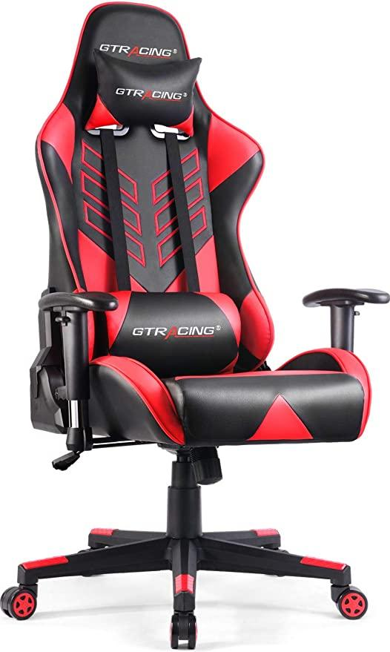

Gaming chairs are all designed with more backrests which provides more comfort to your entire back. Additionally, the cushions you'll find on the seats of these pieces are a bit firmer than your average armchair or even office chair. The price range here can go from ¥18,000 to ¥55,000. There is a surprising amount of choice when it comes to gaming chairs, but that's why we are here to help you find the best option for you.

In this article, we are going to discuss the top 7 gaming chairs with the best specifications and most reviews. So talk no more further, let's get into it.

**Top 7 Best Gaming Chairs:**

* [CORSAIR T1 Race (2018)](https://www.amazon.co.jp/-/en/CORSAIR-Black-Gaming-FT0016-CF-9010012-WW/dp/B077HD3QGH/ref=sr_1_1?dchild=1&keywords=%E3%82%B3%E3%83%AB%E3%82%BB%E3%82%A21%E3%83%AC%E3%83%BC%E3%82%B9&qid=1617804707&sr=8-1)
* [AKRacing Wolf](https://www.amazon.co.jp/-/en/WOLF-GREY-AKRACING-Wolf-Gaming-Chair/dp/B01G8E2ETQ/ref=sr_1_1?dchild=1&keywords=akracing+wolf&qid=1617804650&sr=8-1)
* [AKRacing Pro-X V2](https://www.amazon.co.jp/-/en/AKRacing-Pro-X-V2-GREY-Gaming/dp/B086JTT1GM/ref=sr_1_1?crid=26KEAWX8BRTPY&dchild=1&keywords=akracing+pro-x+v2&qid=1617804599&sprefix=akracing+pro%2Caps%2C462&sr=8-1)
* [AKRacing Nitro V2](https://www.amazon.co.jp/-/en/AKRacing-Nitro-V2-Gaming-Chair/dp/B086JTZJB3/ref=sr_1_3?dchild=1&keywords=%E3%82%B2%E3%83%BC%E3%83%9F%E3%83%B3%E3%82%B0%E3%83%81%E3%82%A7%E3%82%A2&qid=1617872022&rnid=2321255051&s=home&sr=1-3)
* [DOWINX LS-666801F](https://www.amazon.co.jp/-/en/LS-666801F-Recliner-Stretchable-Breathable-Upholstery/dp/B087CMVSTY/ref=sr_1_1?dchild=1&keywords=dowinx&qid=1617804497&sr=8-1)
* [HBADA Gaming Chair](https://www.amazon.co.jp/-/en/Capacity-Reclining-Computer-Headrest-Support/dp/B07WNVQ34J/ref=sr_1_101?dchild=1&keywords=%E3%82%B2%E3%83%BC%E3%83%9F%E3%83%B3%E3%82%B0%E3%83%81%E3%82%A7%E3%82%A2&qid=1617804315&sr=8-101)
* [GalaxHERO ADJY602RE](https://www.amazon.co.jp/-/en/GalaxHERO-ADJY602RE-Goeminku-Sports-Reclining/dp/B08BG3HK56/ref=sr_1_11?dchild=1&keywords=%E3%82%B2%E3%83%BC%E3%83%9F%E3%83%B3%E3%82%B0%E3%83%81%E3%82%A7%E3%82%A2&qid=1617872022&rnid=2321255051&s=home&sr=1-11)

1. CORSAIR T1 Race (2018)

Best-rated gaming chair

**CORSAIR T1 RACE Black & White (2018)**

**Gaming Chair**

**¥ 32,210**

Rating: 4.5 out of 5

1696 reviews

**……………………………………………………………………..**

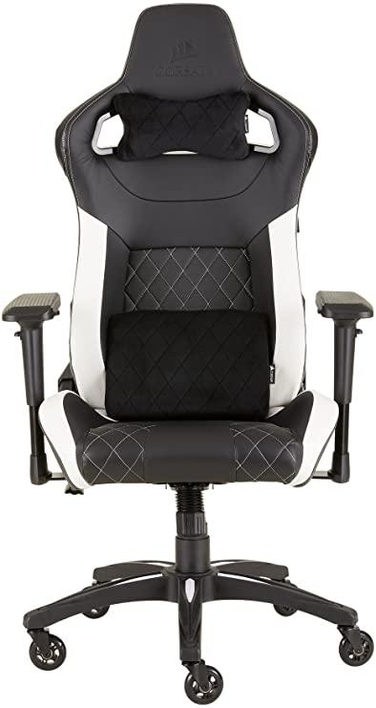

|  |  |
| --- | --- |
| **Brand** | **CORSAIR** |
| **Manufacturer** | **Corsair** |
| **Series** | **CF-9010012-WW** |
| **Product Dimensions** | **52.07 x 55.88 x 95 cm;** |
| **Item model number** | **CF-9010012-WW** |
| **Weight** | **24.04 Kg** |
| **Color** | **Black, Blue, Red, Yellow,**  **White** |

**Product Review**

**………………...**

Corsair is widely known around the world as their products usually rank among the high-end category products. Most of the Corsair products from among coolers, keyboards, cases, SSDs, and PSUs have been tested and reviewed; most of them have left a very good impression. The quality control power of this company is excellent. The gaming chair category 'Corsair'; is a very new brand on the present battlefield and it will be too hard to survive. This IT sector is getting jam-packed with more and more popular brands. This means Corsair will have to offer something more innovative and solid to make its way through to the top.

See more product reviews.

[See more product reviews.](https://www.youtube.com/results?search_query=corsair+t1+race+reviews)

|  |
| --- |
| [Buy it on Amazon](https://www.amazon.co.jp/-/en/CORSAIR-Black-Gaming-FT0016-CF-9010012-WW/dp/B077HD3QGH/ref=sr_1_1?dchild=1&keywords=%E3%82%B3%E3%83%AB%E3%82%BB%E3%82%A21%E3%83%AC%E3%83%BC%E3%82%B9&qid=1617804707&sr=8-1) |

1. AKRacing Wolf

Best fabric gaming chair

**AKRacing Wolf Gaming Chair**

**¥ 44,800**

Rating: 4.5 out of 5

708 reviews

**……………………………………………………….**

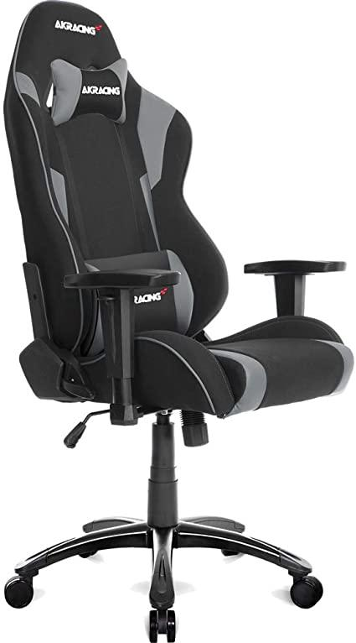

|  |  |
| --- | --- |
| **Brand** | **Akracing** |
| **Model Number** | **WOLF-GREY** |
| **Color** | **Gray, White, Purple, Red** |
| **Cover Material** | **Polyester** |
| **Material Type** | **Cloth / polyester** |
| **Weight** | **25 Kg** |
| **Product Dimensions** | **65 x 65 x 129 cm;** |

**Product Review**

**……………………**

AKRacing Wolf Series is the newest addition to the gaming chair world in recent times. This chair does not compromise on functionality, design, or quality. Keeping deep eyes on the durability and most comfortable of the product, the Wolf Series has been manufactured with a robust metal frame and extra thick seat cushion which is made from high density molded urethane foam in the interior. The Wolf Series is set at a slightly lower height around 124 cm -131 cm but the seat is wider compared to the previous series. This has been designed to offer consumers a cost-effective model. This new series is currently available for purchase on many e-commerce websites and available in different colors.

[See more product reviews.](https://www.youtube.com/results?search_query=akracing+wolf+reviews)

|  |
| --- |
| [**Buy it on Amazon**](https://www.amazon.co.jp/-/en/WOLF-GREY-AKRACING-Wolf-Gaming-Chair/dp/B01G8E2ETQ/ref=sr_1_1?dchild=1&keywords=akracing+wolf&qid=1617856619&sr=8-1) |

1. **AKRacing Pro-X V2**

Best ergonomic gaming chair

**AKRacing Pro-X V2 Gaming Chair**

**¥ 54,321**

Rating: 4.5 out of 5

630 reviews

**…………………………………………...**

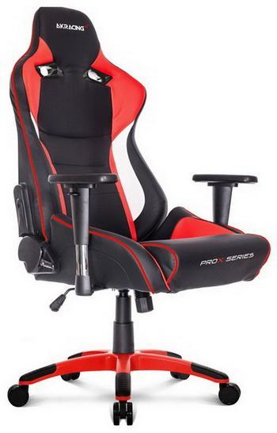

|  |  |
| --- | --- |
| **Brand** | **Akracing** |
| **Model Number** | **AKR-PRO-X/GREY/V2** |
| **Color** | **Grey, Red, Blue, White** |
| **Material Type** | **Polyurethane, Steel** |
| **Weight** | **28 Kg** |
| **Product Dimensions** | **65 x 65 x 127 cm;** |

**Product Review**

**…………………**

Very few gaming chair manufacturers in the world can provide such premier quality as AKRacing.They are producing the highest quality products that are available today in every marketplace.AKRacing gaming chairs have quickly become the smart choice across many consumers as they focus on ergonomics, design, and functionality. The Pro-X V2 may be the current AKRacing flagship but leaving out its a quite larger size makes it ideal for people with large bodies. This might be its strongest selling point and it provides the 3D adjustable armrests. It shares many common features found in other popular gaming chairs.

[See more product reviews.](https://www.youtube.com/results?search_query=akracing+pro+x+v2+review)

|  |
| --- |
| [**Buy it on Amazon**](https://www.amazon.co.jp/-/en/AKRacing-Pro-X-V2-GREY-Gaming/dp/B086JTT1GM/ref=sr_1_1?crid=3SGGC0MQE1BBW&dchild=1&keywords=akracing+pro-x+v2&qid=1617867229&sprefix=akracing+pro%2Caps%2C1898&sr=8-1) |

# AKRacing Nitro V2 Blue Gaming Chair

Best ergonomic gaming chair

# **AKRacing Nitro V2 Blue Gaming Chair**

**¥ 43,593**

Rating: 4.5 out of 5

301 review

**…………………………………………………………………………….**

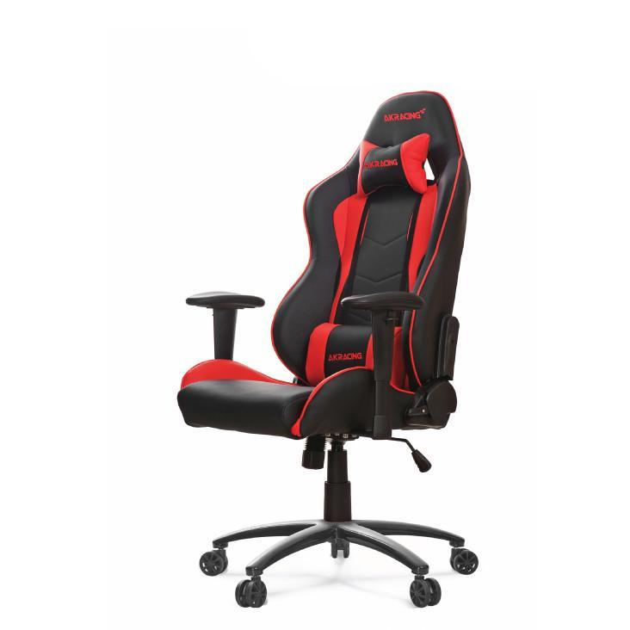

|  |  |
| --- | --- |
| **Brand** | **AKRacing** |
| **Model Number** | **AKR-NITRO-V2** |
| **Color** | **Blue, Orange, Red, White,**  **Green** |
| **Material Type** | **Steel, polyurethane** |
| **Weight** | **28.1 Kg** |
| **Product Dimensions** | **65 x 65 x 125 cm;** |

**Product Review**

**…………………**

This gaming racing chair has commendable features such as adjustable armrests to accommodate comfort, adjustable height, easy tilt feature,free-moving wheels, good balance, instruction manual, easy to build, ergonomic design, and additional back support. However, the narrow build makes this chair uncomfortable for bulky users which can affect consumers' growth for this product. The seat is stiff and the impressive large weight capacity is rather useless apart from this case. Those people should consider other gaming chairs like the DXRacer Tank Series. All in all, it is a durable and sturdy chair with high-quality materials and an attractive exterior.

[See more product reviews](https://www.youtube.com/results?search_query=akracing+nitro+v2+review).

|  |
| --- |
| [Buy it on Amazon](https://www.amazon.co.jp/-/en/AKRacing-Nitro-V2-Gaming-Chair/dp/B086JTZJB3/ref=sr_1_3?dchild=1&keywords=%E3%82%B2%E3%83%BC%E3%83%9F%E3%83%B3%E3%82%B0%E3%83%81%E3%82%A7%E3%82%A2&qid=1617872022&rnid=2321255051&s=home&sr=1-3) |

5. Dowinx LS-666801F Gaming Chair

Best budget gaming chair

# **Dowinx LS-666801F Gaming Chair**

**¥ 18,780**

Rating: 4 out of 5

797 reviews

**………………………………………………………………...**

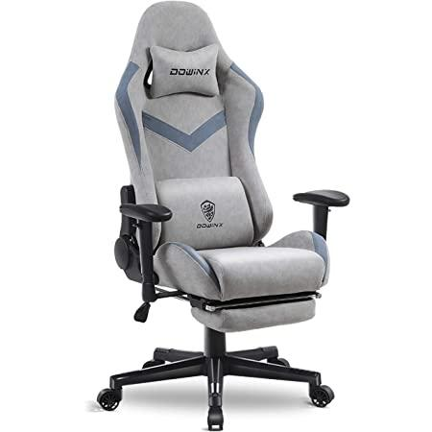

|  |  |
| --- | --- |
| **Brand** | **Dowinx** |
| **Model Number** | **LS-666801F** |
| **Color** | **Gray & Blue, Sky Blue, Black** |
| **Material Type** | **Fabric** |
| **Weight** | **21 kilograms** |
| **Product Dimensions** | **80 x 55 x 132 cm;** |

**Product Review**

**…………………**

The material type of this chair is a little different. If you use this for a long time, your back and waist will get stuffy and sweaty. Breathable fabric keeps you comfortable, not too hot in summer or too cold in winter. Durable and scratch-resistant woven fabric. It feels great on the skin and is ideal for long periods of desk work. Simple but stylish. This chair was built with the concept of a design that releases tension without breaking the atmosphere or feeling. To easily blend in with your room, the concept has been changed and the design of a regular gaming chair has been renewed. See more product reviews. [See more product reviews.](https://www.youtube.com/results?search_query=dowinx+ls-6668)

|  |
| --- |
| [Buy it on Amazon](https://www.amazon.co.jp/-/en/LS-666801F-Recliner-Stretchable-Breathable-Upholstery/dp/B087CMVSTY/ref=pd_rhf_se_p_img_11?_encoding=UTF8&psc=1&refRID=PQTY14P8EVT8CMTH4QX8#customerReviews) |

**6.** Hbada Gaming Chair

Best budget gaming chair

# 

# **Hbada Gaming Chair**

**¥ 18,000**

Rating: 4 out of 5

496 reviews

**………………………………………………………………………..**

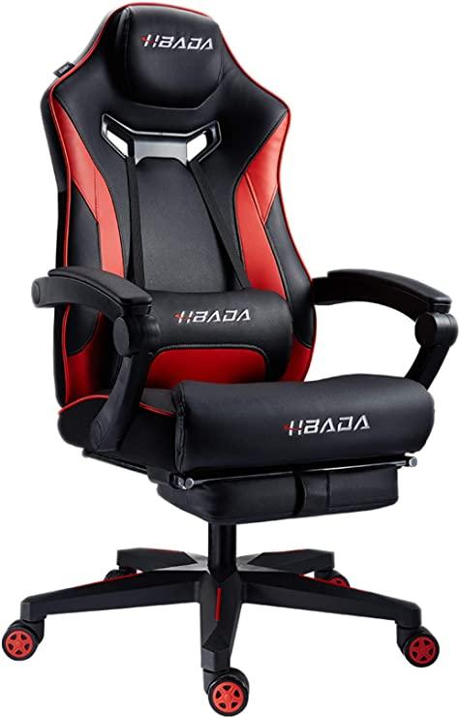

|  |  |
| --- | --- |
| **Brand** | **Hbada** |
| **Color** | **Gray, Blue,White,Red** |
| **Material Type** | **PU (tension material), steel (frame), reinforced nylon resin (base)** |
| **Product Dimensions** | **70 x 70 x 128 cm** |
| **Weight** | **22.5 Kg** |

**Product Review**

**…………………**

We must say that this chair is designed quite uniquely than others. It is designed in such a way to fit 4 points of the head, cervical vertex, shoulders, and hips, absorbs pressure, and maintains a comfortable sitting position. It helps to reduce fatigue, increases gaming and work efficiency. It also allows you to operate your computer, and operate your tablet or smartphone comfortably.No matter how good it is, it doesn't mean if you are not comfortable sitting on it. In response to these voices, the manufacturers use soft leather (PU) that is soft to the touch and used in luxury vehicles. It includes special tools and a Japanese assembly manual so that you can use it for a long time. [See more product reviews.](https://www.youtube.com/results?search_query=hbada+gaming+chair)

|  |
| --- |
| [Buy it on Amazon](https://www.amazon.co.jp/-/en/Capacity-Reclining-Computer-Headrest-Support/dp/B07WNVQ34J/ref=pd_rhf_se_p_img_13?_encoding=UTF8&psc=1&refRID=P4T51JSEXRW77C85JATK) |

7. GalaxHERO ADJY602RE Gaming Chair

Best budget gaming chair

# 

# **GalaxHERO ADJY602RE Gaming Chair**

**¥ 17,800**

Rating: 4 out of 5

450 reviews

**…………………………………………………………………………..**

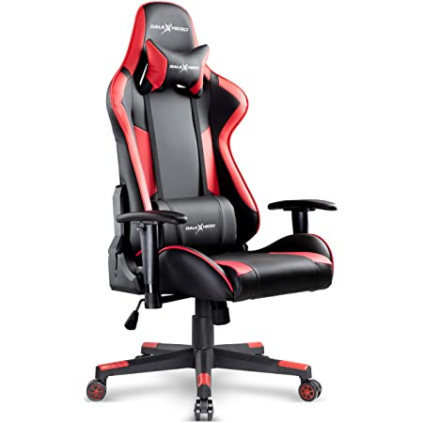

|  |  |
| --- | --- |
| **Brand** | **GalaxHERO** |
| **Model** | **ADJY602RE** |
| **Color** | **Green, Blue, Black, Red** |
| **Material Type** | **Fake Leather** |
| **Product Dimensions** | **67.5 x 62 x 131.5 cm** |
| **Weight** | **18.98 kilograms** |

**Product Review**

**…………………**

Keeping pro gamers in mind, the design of this gaming chair has been inspired by the cockpit, creating a space that you can focus on the game and adds a realistic appearance. To provide a luxurious appearance the manufacturers use high-quality PU leather. Combining stylish design and all outstanding functionalities, this gaming chair is suitable for any style of gamers. You can play games in a natural position, but when you are tired of the game, you can bend your back to rest or nap. Materials used in the interior of the chair are made of non-recycled high-density high resilience urethane foam and ergonomically designed with lumbar support. While long term uses to maintain proper sitting posture and reduces fatigue.GalaxHERO has decades of gaming chair development experience and they ensure a stable sitting experience with less stiffness.

[See more product reviews.](https://www.amazon.com/product-reviews/B07V6BMCRC?reviewerType=all_reviews)

|  |
| --- |
| [Buy it on Amazon](https://www.amazon.co.jp/-/en/GalaxHERO-ADJY602RE-Goeminku-Sports-Reclining/dp/B08BG3HK56/ref=sr_1_11?dchild=1&keywords=%E3%82%B2%E3%83%BC%E3%83%9F%E3%83%B3%E3%82%B0%E3%83%81%E3%82%A7%E3%82%A2&qid=1617872022&rnid=2321255051&s=home&sr=1-11) |